|  |  |
| --- | --- |
|  | Foundation Activity 4 Blinking an LED Using a Microcontroller |

What is the Arduino UNO?

It is an electronics prototyping board with a small computer on it called a microcontroller. We are going to use the Arduino to make our LED light blink.

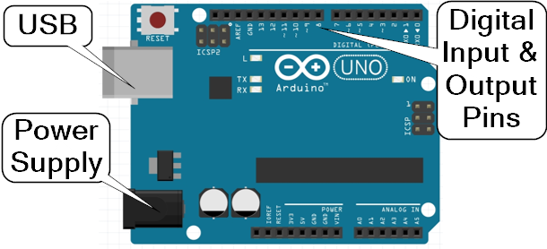

We can write instructions for the Arduino on a computer and upload them using a USB cable. The Arduino can also read sensors (inputs) and control electronic devices (outputs).

Digital Output

Digital output values can be either HIGH or LOW. Like the (+) and (-) sides of a battery, the Arduino board provides +5V and GND. So for the Arduino, 5V represents the digital HIGH value, and 0V represents digital LOW.

|  |  |  |
| --- | --- | --- |
| Battery | Arduino UNO | Digital Value |
| (+) | 5V | HIGH |
| (-) | 0V (GND) | LOW |

Circuit DIagram

Pin set LOW (0V), no current flows:

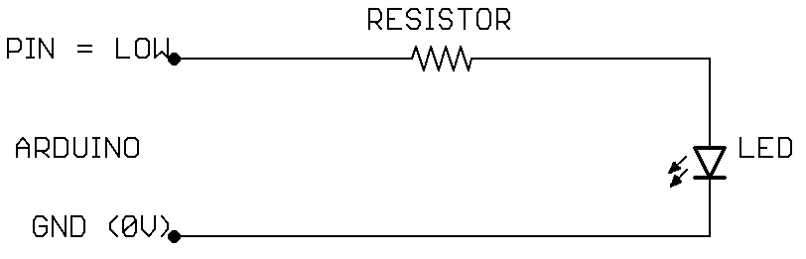

Pin set HIGH (5V), current flows and LED turns on:

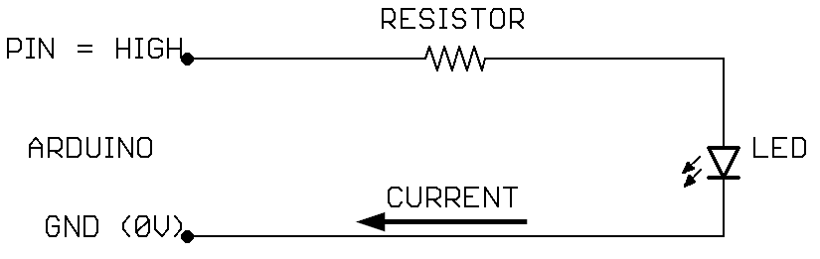

Arduino Instructions Using BLocklyDuino

We will be using BlocklyDuino to write our instructions for the Arduino. Specifically, we will need two types of instruction blocks:

|  |  |
| --- | --- |
|  | **DigitalWrite** allows us to set a pin as HIGH (5V) or LOW (0V) |

|  |  |
| --- | --- |
| C:\Users\Harryp\MEGA\Surface Pro 2\Nepal\Activities\Activity 2\Images\2017-08-19 14_55_57-Clipboard.png | **Delay** will make the Arduino wait for a number of milliseconds. There are 1000 milliseconds in one second. |

To write instructions and upload them to the Arduino board:

1. Open BlocklyDuino program and the Arduino IDE program.
2. Write instructions for the Arduino microcontroller using blocks in BlocklyDuino.
3. Click the “**Arduino**” tab in BlocklyDuino, select the code, and copy it
4. Go to the Arduino IDE and delete any code already there.
5. Paste the code from BlocklyDuino into the Arduino IDE.
6. Make sure the Arduino is connected to the computer using a USB cable
7. Click “**Tools**” on the top menu bar in the Arduino IDE, and make sure that “**Arduino UNO**” is selected under “**Board**”.
8. Click “**Tools**” on the top menu bar in the Arduino IDE, go to “**Port**”, and select the port that appears there after the Arduino is connected.
9. Click the arrow button  to upload the program to the Arduino